**SUMMARY OF PLACEMENT :**

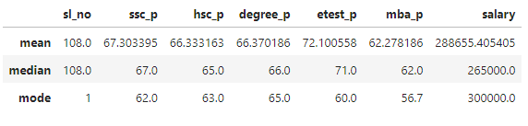

**Mean**: In a class everyone got same average pass mark range up to “ssc” to degree, mba also, alone entrance test they got average as 72.1,here average each: ssc - 67.3, hsc – 66.3,

degree – 66.3,mba – 62.2 they got average salary with outlier 288655.4

In **Median** they got same midvalue as in mean but I found outlier in salary as 265000.

**Mode** : In ssc Repetitively they got 62 marks

Hsc - Repetitively they got 63 marks

degree - Repetitively they got 65 marks

entrance - Repetitively they got 60 marks

mba - Repetitively they got 56 marks

salary - Repetitively they got 300000 salary